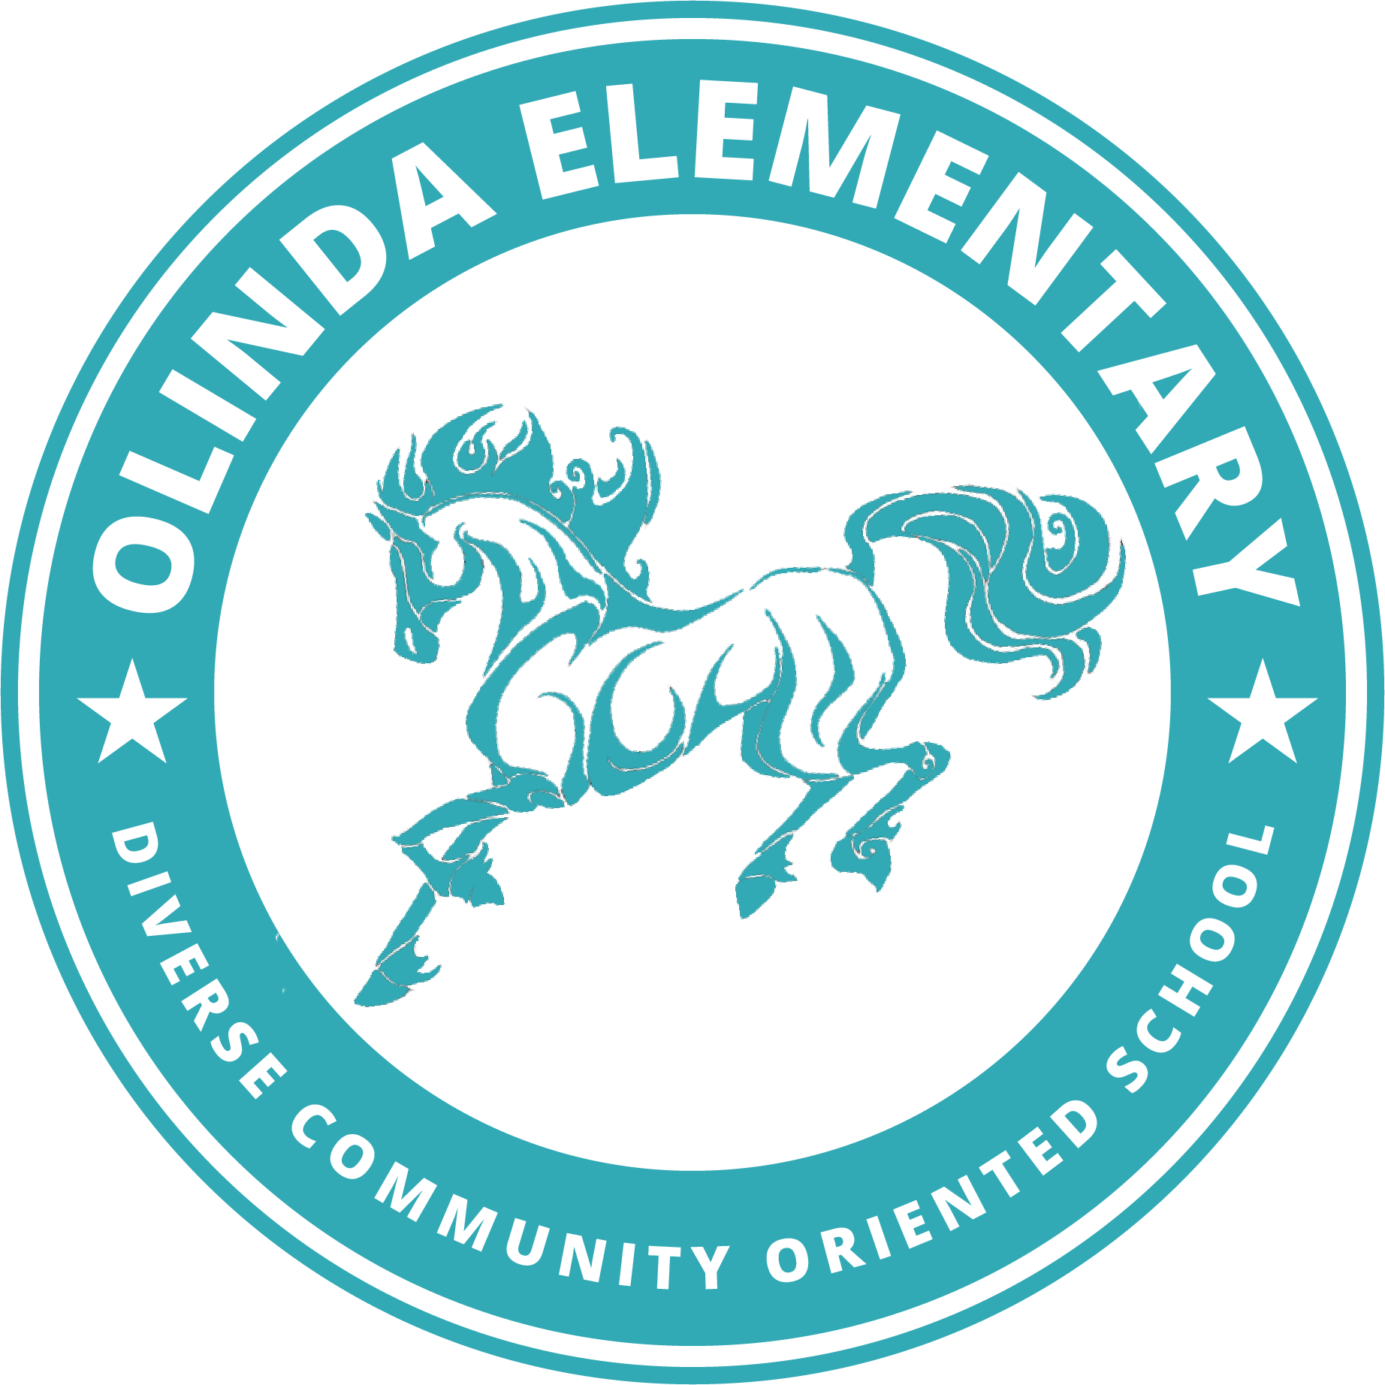

**Room 18 School Supplies**

**Mrs. Burtch**

**Welcome to third grade! I can't wait to see everyone next week. To help us get ready, everyday you will need:**

* Your school assigned, *fully charged* tablet AND the power cord/charger
* At least 3 clean masks
* A water bottle filled ONLY with water

**Requested School Supplies:**

* 2 spiral single subject notebooks
* 1 expanding file folder with at least 6 pockets.

Please label each file with these subjects:

1. Important Papers
2. Math
3. Language Arts
4. Reading
5. Science
6. Social Studies

* 2 two pocket portfolio folders with prongs (preferably plastic so it lasts all year!)
* 1 package of pencils (preferably mechanical but any kind are fine)
* 1 package of copy paper
* 1 pair of blunt-tip scissors
* 1 pencil pouch
* 1 container of Clorox Wipes

**Please label each of the above items with your child’s name.**

**Suggested Donations for Classroom Use:** *(Not required! But if you’d like to make a donation to our classroom, any of these items would be greatly appreciated)*

| Dry erase markers | Hand Sanitizer | 1 box of Kleenex or 1 roll of paper towel |
| --- | --- | --- |
| Lined paper | Post it Notes | Glue Sticks |

**Thank you! I am looking forward to a wonderful year!**